Epsom & Ewell
8
v
Sandhurst Town
Tuesday, 26th November 2019 – 7.45 p.m.
Good evening and welcome to High Road for our latest Combined Counties League match against Sandhurst Town. We welcome their players, supporters and the match officials and hope they have a safe journey home.

It seems that every time we host Sandhurst, I am apologising for the size of the programme, as yet again, partly due to our match just three days previously, and also due to a holiday that was planned before this match was rearranged, I was only able to create a smaller issue.

Our two teams met three times last season; firstly on the opening day when we won 2-0 at Bottom Meadow, and then in November when we edged past them by the only goal scored in extra time in the Division One Cup. Our third meeting in April went the way of our opponents by a 3-1 scoreline in a match where it was all over by half time as we were already three goals down.

We were due to be at High Road on Saturday when we met Dorking Wanderers Reserves but this programme had to go to press before I knew the result of the match. The match report will appear in our next home programme.

Going forward, we visit Godalming Town this Saturday and then visit Fleet Spurs on the following Saturday, with a third consecutive away match coming up on the Monday 9th December when we visit Sutton United Development XI in the Surrey Premier Cup at Gander Green Lane. We then return home for a League fixture with Bedfont & Feltham on Saturday 14th December.

We are still looking for match and player sponsors so don’t be shy! Just ask a Committee member for details. Many new players will be appearing on the programme picture list shortly too, so if you see a player you like the look of, just let us know!

Enjoy the game!

Rich

You can follow us on social media – just see the inside cover for details.

Cover photo by Gemma Jarman

The team pose for the cameras at their
hotel in Jersey on Sunday morning

Cherry Red Records Combined Counties League
Division One Table 2019/20
incl Tuesday 19th November | P | W | D | L | F | A | Pts | GD | H | A

Jersey Bulls | 15 | 15 | 0 | 0 | 57 | 5 | 45 | +52 | 13/4 | 0-2
Farnham Town | 12 | 9 | 2 | 1 | 28 | 10 | 29 | +18 | 0-2 | 15/2
Tooting Bec | 13 | 8 | 4 | 1 | 35 | 17 | 28 | +18 | 2-2 | 1-2
Walton & Hersham | 14 | 8 | 2 | 4 | 40 | 24 | 26 | +16 | 31/3 | 3-6
Kensington & Ealing Boro | 14 | 8 | 0 | 6 | 34 | 29 | 24 | +5 | 21/1 | 1-3
Sandhurst Town | 13 | 6 | 4 | 3 | 25 | 19 | 22 | +6 | 26/11 | 14/3
Westside | 14 | 6 | 2 | 6 | 30 | 22 | 20 | +8 | 28/12 | 3-1
AFC Hayes | 13 | 6 | 2 | 5 | 34 | 27 | 20 | +7 | 1-4 | 18/1
Dorking Wanderers Res | 16 | 6 | 2 | 8 | 34 | 39 | 20 | -5 | 23/11 | 11/4
British Airways | 15 | 5 | 4 | 6 | 26 | 36 | 19 | -10 | 11/1 | 29/2
FC Deportivo Galicia | 16 | 5 | 4 | 7 | 20 | 38 | 19 | -18 | 3-0 | 1/2
Bedfont & Feltham | 13 | 5 | 2 | 6 | 26 | 25 | 17 | +1 | 14/12 | 18/4
Cove | 13 | 4 | 4 | 5 | 24 | 36 | 16 | -12 | 25/1 | 2-2
Fleet Spurs | 14 | 5 | 0 | 9 | 26 | 32 | 15 | -6 | 3-5 | 7/12
Ash United | 15 | 5 | 0 | 10 | 25 | 41 | 15 | -16 | 8/2 | 2-1
Epsom and Ewell | 14 | 4 | 2 | 8 | 27 | 34 | 14 | -7 | x | x
Chessington & Hook Utd | 12 | 3 | 5 | 4 | 20 | 23 | 11* | -3 | 22/2 | 19/11
Godalming Town | 13 | 3 | 2 | 8 | 24 | 39 | 11 | -15 | 5-2 | 30/11
Bagshot | 13 | 3 | 2 | 8 | 16 | 32 | 11 | -16 | 4/4 | 1-2
Eversley & California | 14 | 1 | 3 | 10 | 13 | 36 | 6 | -23 | 21/3 | 21/12
* Chessington & Hook United – 3 points deducted for playing an ineligible player on 3rd August v Godalming Town

Lucky Day? – 26th November
Played 17 - Won 8 Drawn 3 Lost 6 - For 52 Against 44 - PPG 1.59 - Above Average
Our Club record against Sandhurst Town
Played 17 - Won 7 Drawn 0 Lost 10 - For 29 Against 31 - PPG 1.24 - Below Average
Our Largest wins and losses against Sandhurst Town
Saturday, 6th October 2012 - W 4-0 - Combined Counties League (H)
Saturday, 7th August 2010 - L 1-3 - Combined Counties League (A)
Saturday, 17th September 2011 - L 1-3 - Combined Counties League (A)
Saturday, 20th April 2019 - L 1-3 - Combined Counties League (H)
Sandhurst Town‘s Last Visit
Saturday, 20th April 2019 - Lost 1-3 - Combined Counties League Division One

First Eleven Appearances - (max 17)
Name | Debut | 2019/20 |  |  |  | Career Totals
 |  | App | Sub | Tot | Goals | App | Sub | Tot | Goals
BENNETT Bobby | 12/08/2018 | 12 | 3 | 15 | 5 | 53 | 3 | 56 | 28
BETANCOURT Steve | 18/08/2018 | 0 | 1 | 1 | 0 | 21 | 2 | 23 | 1
BONASS-WARD Joe | 10/08/2019 | 11 | 2 | 13 | 0 | 11 | 2 | 13 | 0
CARNEY Billy* | 12/01/2019 | 1 | 2 | 3 | 2 | 13 | 7 | 20 | 8
CARTON Kyle | 03/08/2019 | 4 | 0 | 4 | 0 | 4 | 0 | 4 | 0
CHIN Louis* | 08/12/2018 | 6 | 1 | 7 | 0 | 19 | 2 | 21 | 0
CONNELLY Lloyd | 14/10/2017 | 15 | 1 | 16 | 2 | 93 | 5 | 98 | 8
DAVIES Felix* | 03/08/2019 | 11 | 0 | 11 | 0 | 11 | 0 | 11 | 0
FRAY James | 12/11/2019 | 2 | 0 | 2 | 0 | 2 | 0 | 2 | 0
FUNNELL Toby | 03/08/2019 | 13 | 1 | 14 | 1 | 13 | 1 | 14 | 1
GALLAGHER Jordan* | 07/08/2016 | 8 | 2 | 10 | 3 | 57 | 15 | 72 | 21
HEAGNEY Adam | 16/08/2016 | 11 | 0 | 11 | 1 | 125 | 13 | 138 | 4
HENDRY Rob | 08/08/2015 | 7 | 7 | 14 | 4 | 117 | 31 | 148 | 50
KING Jahmahl | 26/10/2019 | 4 | 0 | 4 | 0 | 4 | 0 | 4 | 0
LEWIS Rory | 03/08/2019 | 1 | 1 | 2 | 0 | 1 | 1 | 2 | 0
MARTIN Chaz-Lee | 03/08/2019 | 8 | 0 | 8 | 2 | 8 | 0 | 8 | 2
MORGAN Sam | 11/09/2018 | 0 | 1 | 1 | 0 | 3 | 10 | 13 | 0
MURPHY Scott | 20/01/2007 | 15 | 0 | 15 | 4 | 106 | 2 | 108 | 13
MURPHY Todd | 27/11/2018 | 8 | 0 | 8 | 0 | 11 | 9 | 20 | 0
NIGHTINGALE Zak | 03/08/2019 | 3 | 4 | 7 | 1 | 3 | 4 | 7 | 1
PINDER Marlon | 13/01/2018 | 2 | 0 | 2 | 1 | 15 | 1 | 16 | 3
ROBERTS Liam | 12/08/2017 | 3 | 8 | 11 | 2 | 53 | 29 | 82 | 19
ROBINSON Jake | 23/02/2019 | 13 | 2 | 15 | 1 | 22 | 3 | 25 | 1
SMITH George | 16/11/2019 | 1 | 0 | 1 | 0 | 1 | 0 | 1 | 0
SMITH Taryn | 28/10/2017 | 10 | 2 | 12 | 2 | 24 | 13 | 37 | 7
STRAKER Tariq | 16/11/2019 | 1 | 0 | 1 | 0 | 1 | 0 | 1 | 0
SULLIVAN Ryan* | 04/08/2018 | 1 | 0 | 1 | 0 | 31 | 2 | 33 | 0
TEIXEIRA Ricardo* | 19/10/2019 | 4 | 0 | 4 | 0 | 4 | 0 | 4 | 0
THOMPSON Ashley* | 21/08/2017 | 1 | 0 | 1 | 0 | 36 | 1 | 37 | 5
WHITE Sean | 02/08/2014 | 9 | 4 | 13 | 0 | 38 | 29 | 67 | 9
YOUNG Conor | 07/03/2015 | 2 | 0 | 2 | 0 | 63 | 0 | 63 | 0
* Player has left the club

Latest Results and Fixtures
Combined Counties League Cup 2nd Round – Tuesday 19th November
Abbey Rangers | 1-0 | Raynes Park Vale
Esoteric Division One Cup 2nd Round – Tuesday 19th November
Walton & Hersham | 1-0 | AFC Hayes
Combined Counties League – Tuesday 19th November
Ash United | 2-1 | Westside
Chessington & Hook Utd | p-p | Epsom & Ewell
Eversley & California | 2-2 | Godalming Town
Combined Counties League – Saturday 23rd November
Bagshot | V | Walton & Hersham
Bedfont & Feltham | V | Godalming Town
Epsom & Ewell | V | Dorking Wanderers Res
Eversley & California | V | Chessington & Hook United
Farnham Town | V | AFC Hayes
Fleet Spurs | V | British Airways
Jersey Bulls | V | Cove
Kensington & Ealing Borough | V | FC Deportivo Galicia
Tooting Bec | V | Ash United
Westside | V | Sandhurst Town
Combined Counties League – Tuesday 26th November
AFC Hayes | V | British Airways
Epsom & Ewell | V | Sandhurst Town
Combined Counties League – Wednesday 27th November
Westside | V | Godalming Town
Combined Counties League – Saturday 30th November
AFC Hayes | V | Westside
Ash United | V | Kensington & Ealing Borough
British Airways | V | Dorking Wanderers Reserves
Chessington & Hook United | V | Walton & Hersham
Cove | V | Tooting Bec
Eversley & California | V | Fleet Spurs
FC Deportivo Galicia | V | Bagshot
Godalming Town | V | Epsom & Ewell
Jersey Bulls | V | Farnham Town
Sandhurst Town | V | Bedfont & Feltham
Combined Counties League – Tuesday 3rd December
Bedfont & Feltham | V | Cove
Eversley & California | V | Farnham Town
Latest Results and Fixtures
Combined Counties League Cup 1st Round – Tuesday 3rd December
Spelthorne Sports | V | Chessington & Hook United
Combined Counties League Cup 2nd Round – Tuesday 3rd December
Badshot Lea | V | Dorking Wanderers Reserves
Esoteric Division One Cup 2nd Round – Tuesday 3rd December
Fleet Spurs | V | Westside
Combined Counties League – Saturday 7th December
Ash United | V | Eversley & California
Bagshot | V | Westside
Bedfont & Feltham | V | FC Deportivo Galicia
Chessington & Hook United | V | Farnham Town
Fleet Spurs | V | Epsom & Ewell
Godalming Town | V | Cove
Kensington & Ealing Borough | V | AFC Hayes
Sandhurst Town | V | British Airways
Tooting Bec | V | Jersey Bulls
Walton & Hersham | V | Dorking Wanderers Reserves
Combined Counties League Cup 2nd Round – Tuesday 10th December
Banstead Athletic | V | AFC Hayes
Camberley Town | V | Colliers Wood United
CB Hounslow United | V | Balham
Combined Counties League – Tuesday 10th December
Cove | V | Bagshot
Farnham Town | V | Fleet Spurs
Kensington & Ealing Borough | V | Chessington & Hook United
Sandhurst Town | V | Ash United
Tooting Bec | V | Bedfont & Feltham
Combined Counties League – Saturday 14th December
AFC Hayes | V | Chessington & Hook United
Bagshot | V | Kensington & Ealing Borough
British Airways | V | Ash United
Cove | V | Fleet Spurs
Dorking Wanderers Reserves | V | Farnham Town
Epsom & Ewell | V | Bedfont & Feltham
FC Deportivo Galicia | V | Sandhurst Town
Jersey Bulls | V | Godalming Town
Walton & Hersham | V | Tooting Bec
Westside | V | Eversley & California

This Day in History – 26th November
Date | Day | Competition |  | Opponents |  | Scorers
26/11/27 | Sat | Surrey Senior Cup 3q | H | Aquarius | 7-3 | R.Marlow (3), J.Parr (2), F.Watts, F.Behn
26/11/32 | Sat | London League | H | Hendon | 5-5 | B.Williams (3), R.Marlow (2)
26/11/38 | Sat | London League | A | R.N.Depot | 4-1 | R.Forbes, A.Curtis, B.Solly, J.Jones
26/11/49 | Sat | Corinthian League | A | Edgware Town | 3-6 | F.Marshall, R.Orford, T.Wright
26/11/55 | Sat | Amateur Cup 4q | A | Redhill | 1-2 | D.Hermitage
26/11/60 | Sat | Corinthian League | H | Slough Town | 5-4 | T.Flynn (2), M.Simmons (pen), D.Mollatt, D.Mead
26/11/66 | Sat | Athenian League Div 2 Cup 1 replay | H | Rainham Town | 1-4 | T.Williams
26/11/77 | Sat | F.A. Vase 2 | H | East Ham United | 3-0 | G.Butler, R.Parkin, T.Tuite
26/11/83 | Sat | Isthmian League 1 | A | Lewes | 3-2 | S.Hill (2, 1 pen), o.g.
26/11/85 | Tue | Isthmian League Cup 2 | H | Bishop's Stortford | 3-1 | D.Jones (2), T.Tuite
26/11/88 | Sat | F.A. Vase 2 | H | Three Bridges | 6-2+ | N.Robson (2), P.Andrews, B.Perkins, C.Walcott, C.Holding
26/11/94 | Sat | Isthmian League 3 | A | East Thurrock United | 4-1 | P.Meredith, T.Hoy (pen), T.O'Connor, S.Smith
26/11/02 | Tue | Isthmian League 1s | H | Dulwich Hamlet | 3-3 | J.Hall, K.Webb, S.Huckle
26/11/05 | Sat | Isthmian League 2 | A | Wembley | 2-4 | N.Williams, L.Gay
26/11/11 | Sat | Combined Counties Premier Division | A | Windsor | 0-1
26/11/13 | Tue | Surrey Senior Cup 2 | A | Chipstead | 0-3
26/11/16 | Sat | Combined Counties Premier Division | H | AFC Hayes | 2-2 | D.Cooper-Smith, S.Panayioutou
Historical Decades
Date | Day | Competition |  | Opponents |  | Scorers
100 years ago – Epsom Juniors F.C.
22/11/19 | Sat | Surrey Junior League | H | British Red Cross | 2-0 | C.Aldridge, o.g.
90 years ago – Epsom Town F.C.
23/11/29 | Sat | London League | A | Erith & Belvedere | 1-2 | J.Parr
70 years ago – Epsom F.C.
26/11/49 | Sat | Corinthian League | A | Edgware Town | 3-6 | F.Marshall, R.Orford, T.Wright
60 years ago – Epsom F.C.
28/11/59 | Sat | Corinthian League | H | Letchworth | 3-1 | C.Coughlan (2), J.Blizzard
50 years ago – Epsom & Ewell F.C.
29/11/69 | Sat | Athenian League 2 | A | Rainham Town | 0-2
40 years ago – Epsom & Ewell F.C.
27/11/79 | Tue | Isthmian League 1 | H | Kingstonian | 1-4 | R.Beswick
30 years ago – Epsom & Ewell F.C.
18/11/89 | Sat | Isthmian League 2s | A | Feltham | 3-0 | R.Kidd, P.Andrews, C.Walcott
20 years ago – Epsom & Ewell F.C.
27/11/99 | Sat | Isthmian League 3 | A | Bracknell Town | 3-1 | A.Nimmo, S.Grant, R.Sell
10 years ago – Epsom & Ewell F.C.
28/11/09 | Sat | Combined Counties Premier Division | H | Horley Town | 2-0 | R.Burns, A.Amfo-Brobbey
History Corner – 26th November
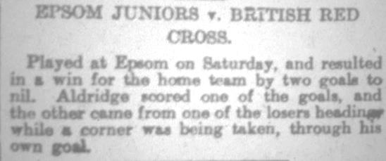
100 years ago this month we defeated British Red Cross by two goals to nil in the Surrey Junior League to register the first ever competitive win in our history. A goal from Charlie Aldridge was added to by an own goal as we climbed off the bottom of the table. Unfortunately, our opponents would fold later in the season and we would not win another match, leaving us at the foot in our first season. Better times were coming though with two Surrey Senior League titles and a London League win, not to mention various cups and a Surrey Senior Cup Final, all in the next ten years! (see report above)

82 years ago today we said goodbye to a founder member of the club as Reg Sperring advised that he would be leaving the country to become a golf professional in Europe. Yes, he was good at golf too! We hosted Aquarius, the Water Board Works team in a Surrey Senior Cup tie in his last match and won 7-3 with Reg Marlow scoring a hat trick. After the match there were many presentations, but he was not away for that long and was actually due to play for our Reserves a couple of years later, although he would never again represent the first team.

79 years ago today we staged a very odd match against Hendon, who were not connected to the current club that exists today, although they were decent and played in the London League, where we met them at West Street. They led 1-0 at the half, but we turned it around and led 5-2 after Billy Williams had scored three goals and with just 15 minutes remaining, we looked set for a comfortable win but they fought back to make it 5-5 and that’s how it finished!

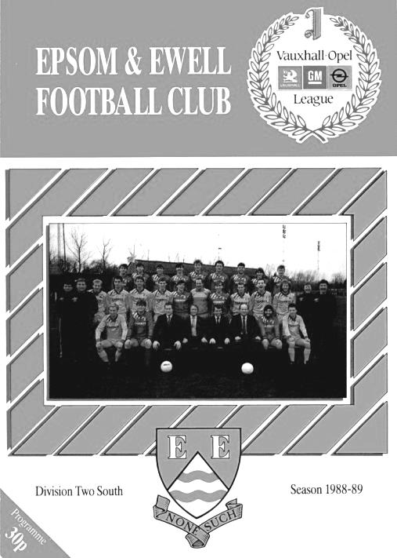
31 years ago today we hosted Three Bridges at West Street in another bizarre match. They were a very strong Sussex League team but in the F.A. Vase strange things can happen and although we trailed at the half, an equaliser forced extra time at 1-1, which was when things got seriously weird as six goals were scored in the extra period, five of which ended in the Three Bridges net as we won 6-2! It was our second match in the Vase that season to go to extra time and there would be a further three before we were defeated in the Fourth Round by Hailsham Town 2-1 also after extra time. We had led that with three minutes remaining but couldn’t hold on and have still to pass the fourth round of the competition since the famous 1974/75 season. (see programme pictured)

Centre page for results

Centre page for results

Sandhurst Town F.C. – History
Sandhurst Football Club was formed in 1910 and played in the Reading & District League until 1979 apart from a short spell in the East Berkshire Football League. In 1979, the Club was elected into the Aldershot & District Football League. 1984 saw the Club finish as runners-up from whence they became founder members of the Chiltonian Football League and a stepping-stone toward becoming a senior club.

The best season in the Chiltonian Football League was in 1986-1987 when they finished in second place. In 1990 the Club applied for membership of the Combined Counties Football League and were granted senior status by the Berks & Bucks County Football Association. The first two seasons were disastrous finishing in bottom place on each occasion and only escaped relegation back to the Chiltonian Football League at the end of the second season due to the resignation of another member club. However, the form of the Club improved dramatically thereafter over a number of years with Managers Peter Browning and subsequently John Underwood bringing the club cup and league success.

The first ground used by the Club was a field adjacent to the Bull & Butcher public house that may well have been used as the club headquarters. After a few years, a move was made to the Memorial Park where the Club remained until the 1996 close season, apart from a couple of seasons during the 1950’s spent on a nearby pitch in St. John’s Road.

The introduction of the National Lottery prompted an immediate bid for funding for a new ground in Bottom Meadow adjacent to the Memorial Park. With support and backing through additional matched funding from Bracknell Forest Borough Council and Sandhurst Town Council, the Club were successful in the first round of allocations by the National Lotteries Charities Board.

The introduction of the National Lottery prompted an immediate bid for funding for a new ground in Bottom Meadow adjacent to the Memorial Park. With support and backing through additional matched funding from Bracknell Forest Borough Council and Sandhurst Town Council, the Club were successful in the first round of allocations by the National Lotteries Charities Board. The new facilities opened in August 1997 at a cost of £265,000. The club celebrated its Centenary season in 2010/11 winning the Combined Counties League Cup Final and getting through to two other semi-finals.

The club today has a strong stable, business, financial and community focus with our 1st team playing in Division 1 of the Combined Counties League. With Michael Herbert and Darryl Jelly starting their second season in charge they have taken the opportunity to strengthen their management team with Ryan Weeks joining as goal keeper coach and Jack Dumbleton as coach/analyst. All the latest Fizzers news on Twitter @sandhursttownfc.

Player Sponsorship
Here is the latest list of players for 2019/20, with photos showing all of our boys and also our Management team that are available for sponsorship. These will be updated shortly. Thanks as always to our Club Photographer Gemma Jarman.

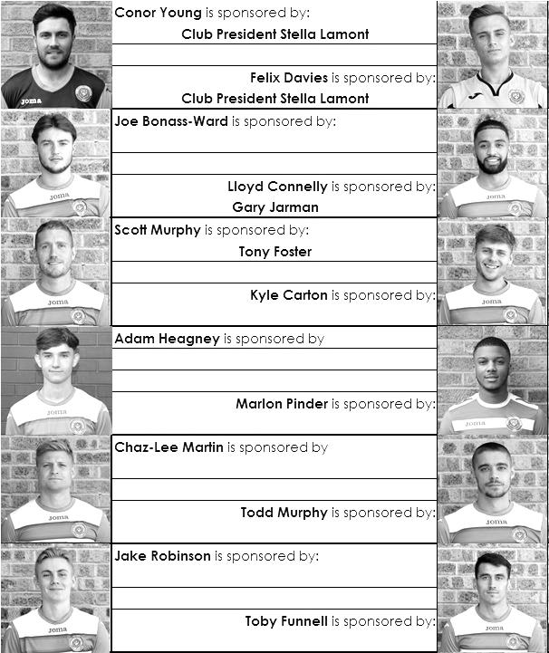

Sponsorship costs just £40 and it is easy to do. Just select a player who has not been previously sponsored and let a Committee Member know that you would like to sponsor them. Beware though. Until we have received the money it is possible for someone to jump in front of you, so don’t delay, sponsor today!

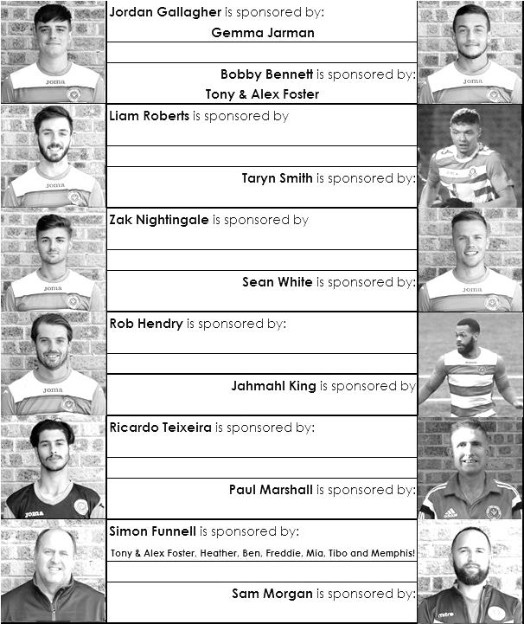

Match and Ball Sponsorships – 2019/20
Opponent | Date | Match Sponsor | Ball Sponsor
Fleet Spurs | 03/08/19 | Club President - Stella Lamont
Godalming Town | 20/09/19 | Paul Merritt
Tooting Bec | 27/09/19 | EEFC Management Committee
Kennington (FA Vase) | 31/08/19 | Geoff Dyke – celebrating his 70th birthday
AFC Hayes | 21/09/19 | Alex McKay (senior)
Farnham Town | 28/09/19 | Philip Harris
FC Deportivo Galicia | 19/10/19
Dorking Wanderers Res | 23/11/19
Sandhurst Town | 26/11/19
Bedfont & Feltham | 14/12/19
Westside | 28/12/19
British Airways | 11/01/20
Kensington & Ealing Borough | 21/01/20
Cove | 25/01/20
Ash United | 08/02/20
Chessington & Hook United | 22/02/20
Eversley & California | 21/03/20
Walton & Hersham | 31/03/20 | Tony Foster
Bagshot | 04/04/20
Jersey Bulls | 13/04/20 | Club President - Stella Lamont
Match sponsorship costs just £60.00!

Sponsorship includes:

Admission, programmes and hospitality for three people.

A full page advert in the programme and mascot for the day (if required).

Also, you get to choose the player of the match, who will receive a prize

If you are interested, just speak to a Committee Member,
or drop me an email at: richard.c.lambert@gmail.com

Combined Counties League Division One
Opponents All-time Records
inc 16th November 2019 | P | W | D | L | F | A | PPG | GD | Best  Win | Worst  Loss
Westside | 1 | 1 | 0 | 0 | 3 | 1 | 3.00 | +2 | 3-1 | -
Godalming Town | 7 | 6 | 0 | 1 | 20 | 11 | 2.57 | +9 | 5-1 | 0-3
Bagshot | 4 | 3 | 0 | 1 | 12 | 3 | 2.25 | +9 | 7-1 | 1-2
FC Deportivo Galicia | 4 | 3 | 0 | 1 | 10 | 4 | 2.25 | +7 | 3-0 | 0-2
Bedfont & Feltham | 6 | 4 | 1 | 1 | 26 | 15 | 2.16 | +11 | 9-2 | 1-3
Ash United | 22 | 12 | 4 | 6 | 52 | 33 | 1.82 | +19 | 6-0 | 0-3
Cove | 37 | 17 | 10 | 10 | 82 | 60 | 1.65 | +22 | 7-0 | 1-6
Chessington & Hook | 30 | 13 | 9 | 8 | 63 | 45 | 1.60 | +18 | 6-0 | 1-3
Walton & Hersham | 55 | 25 | 11 | 19 | 108 | 111 | 1.56 | -3 | 8-0 | 0-8
Farnham Town | 20 | 9 | 4 | 7 | 32 | 33 | 1.55 | -1 | 3-0 | 1-4
Dorking Wanderers Res | 2 | 1 | 0 | 1 | 6 | 5 | 1.50 | +1 | 3-0 | 3-5
British Airways | 2 | 1 | 0 | 1 | 5 | 5 | 1.50 | 0 | 3-2 | 2-3
Eversley & California | 2 | 1 | 0 | 1 | 2 | 2 | 1.50 | 0 | 1-0 | 1-2
Fleet Spurs | 3 | 1 | 1 | 1 | 7 | 8 | 1.33 | -1 | 3-2 | 3-5
Sandhurst Town | 17 | 7 | 0 | 10 | 29 | 31 | 1.24 | -2 | 4-0 | 1-3
Tooting Bec | 4 | 1 | 1 | 2 | 7 | 9 | 1.00 | -1 | 3-1 | 1-4
AFC Hayes  (inc Brook House) | 13 | 2 | 4 | 7 | 19 | 24 | 0.77 | -5 | 7-0 | 1-4
Kensington Borough | 3 | 0 | 1 | 2 | 3 | 9 | 0.33 | -6 | - | 1-5
Jersey Bulls | 1 | 0 | 0 | 1 | 0 | 2 | 0.00 | -2 | - | 0-2

Combined Counties League – Division One
Tuesday, 26th November 2019 - Kick-off 7.45 p.m.
Epsom and Ewell  (Royal Blue & White hoops) | V |  | Sandhurst Town  (All Yellow)
Squad | NUMBERS |  | Squad
Conor Young |  |  | Andy Rider
Steve Betancourt |  |  | Ryan Howells
George Smith |  |  | Joe Barley
Reisse Griffin |  |  | Luke Cox
Adam Heagney |  |  | Luke Burrows
Lloyd Connelly |  |  | Mitchel Cooper
Jahmahl King |  |  | Grant Kemp
Chaz-Lee Martin |  |  | Michael Herbert
Joe Bonass-Ward |  |  | Bradley Brown
Todd Murphy |  |  | Ashley Ledger
Kyle Carton |  |  | Owen Davies
© Scott Murphy |  |  | Jamie Mitchell
Sean White |  |  | Thomas Cooper
Jake Robinson |  |  | Marvin Hinds
James Fray |  |  | Callum Samuel-Harman
Tariq Straker |  |  | Haydon Richardson
Toby Funnell |  |  | Jordan Goddard
Marlon Pinder |  |  | Patrick Gardner
Bobby Bennett |  |  | Luke Turner
Rob Hendry
Taryn Smith
Simon Funnell | MANAGER |  | Michael Herbert
Sam Morgan / Paul Marshall | ASSISTANTS |  | Darryl Jelly
Sam Morgan | COACHES |  | Ryan Howells /  Jack Dumbleton
Sam Morgan | PHYSIO
REFEREE: F. Le Houezec
ASSISTANTS: P.Crichlow, R. van Niekerk

OUR NEXT VISITORS TO HIGH ROAD
Bedfont & Feltham
Combined Counties League – Division One
Saturday, 14th December 2019 – Kick-off – 3.00 p.m.

